signInAuthenticationFailed- email:micorreo1@correo.com, password: micontraFalsa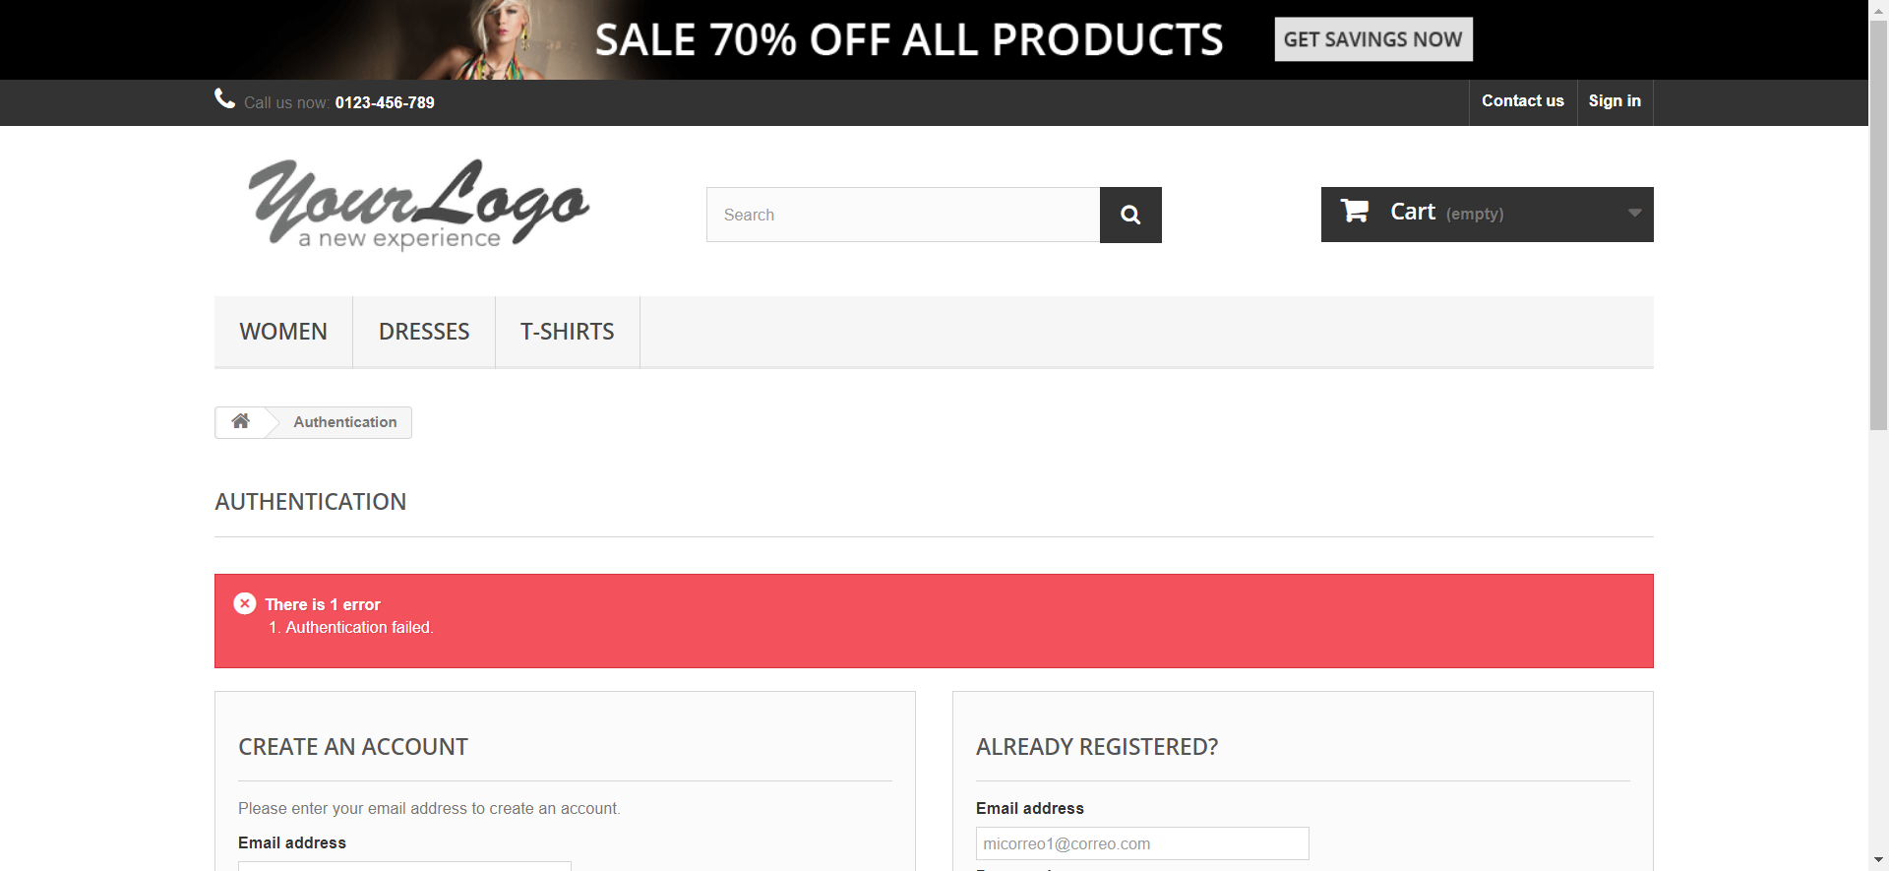

signInEmailInvalido- email:testgmail.com, password: ABCD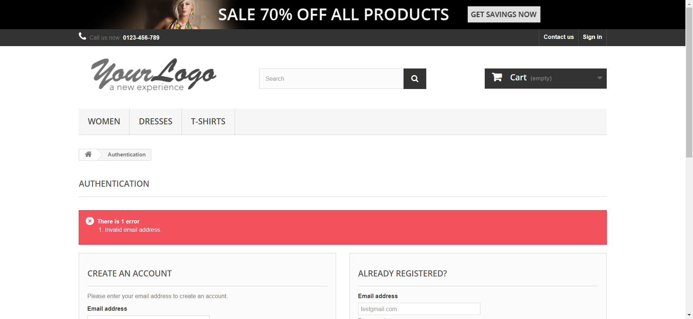

signInEmailInvalido- email:test@gmailcom, password: ABCD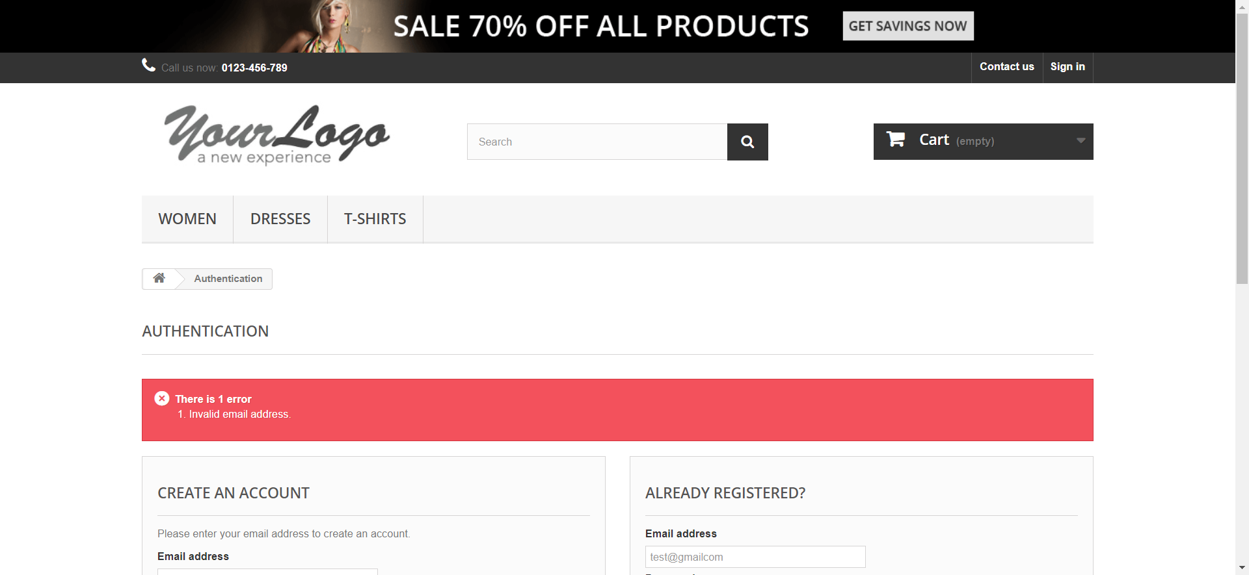

signInEmailInvalido- email:test@gmail., password: ABCD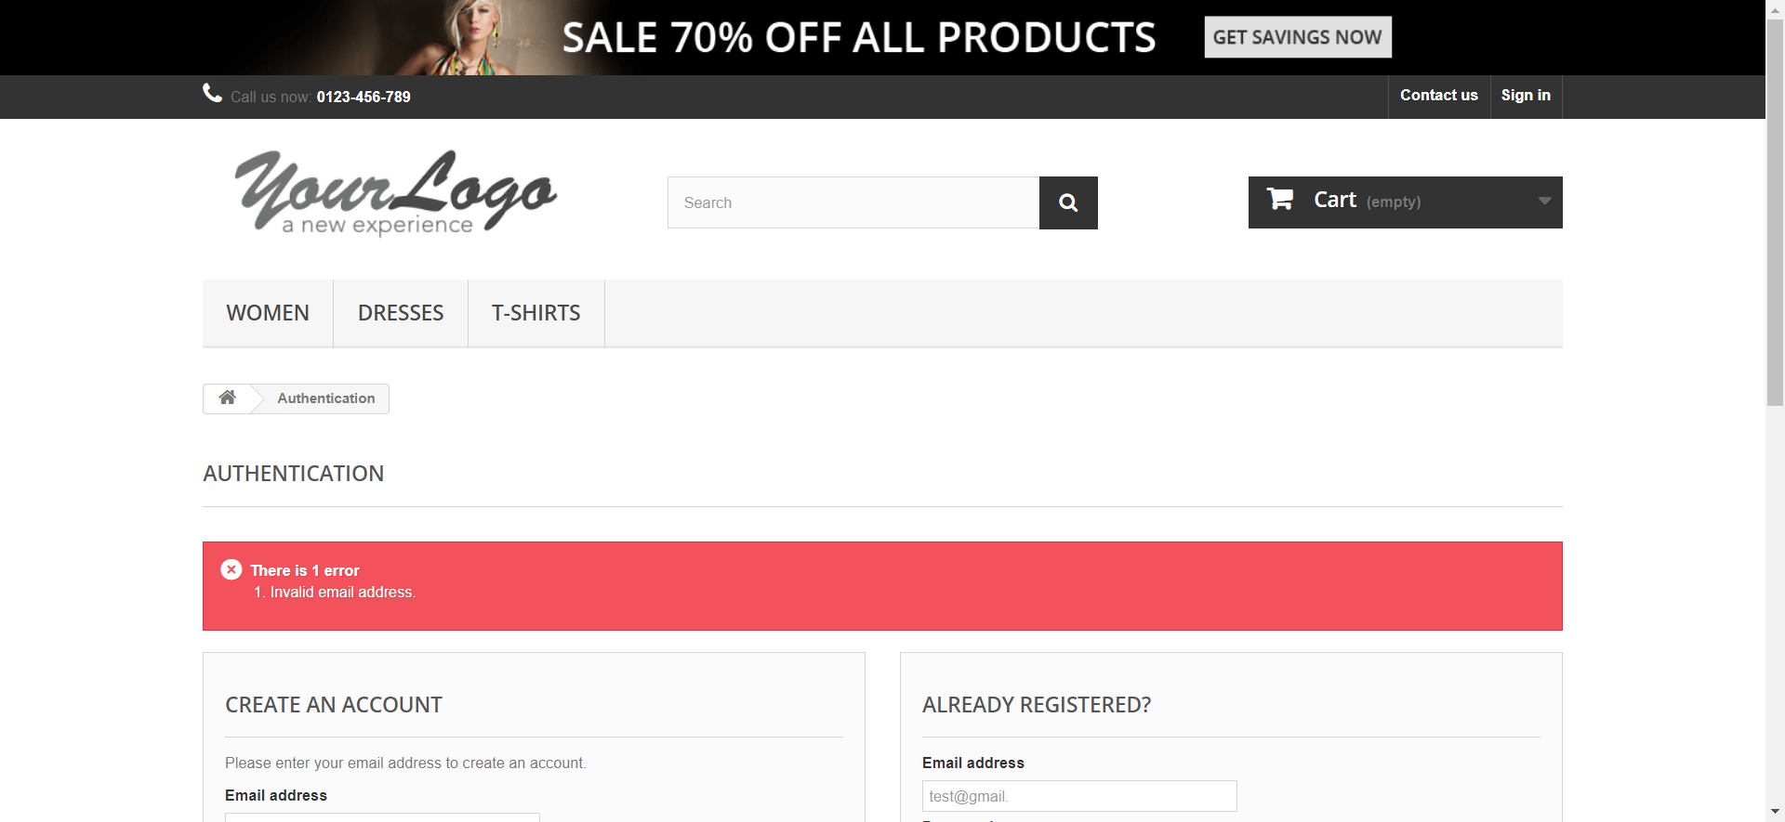

signInInvalidPassword- email:test@gmail.com, password: ABCD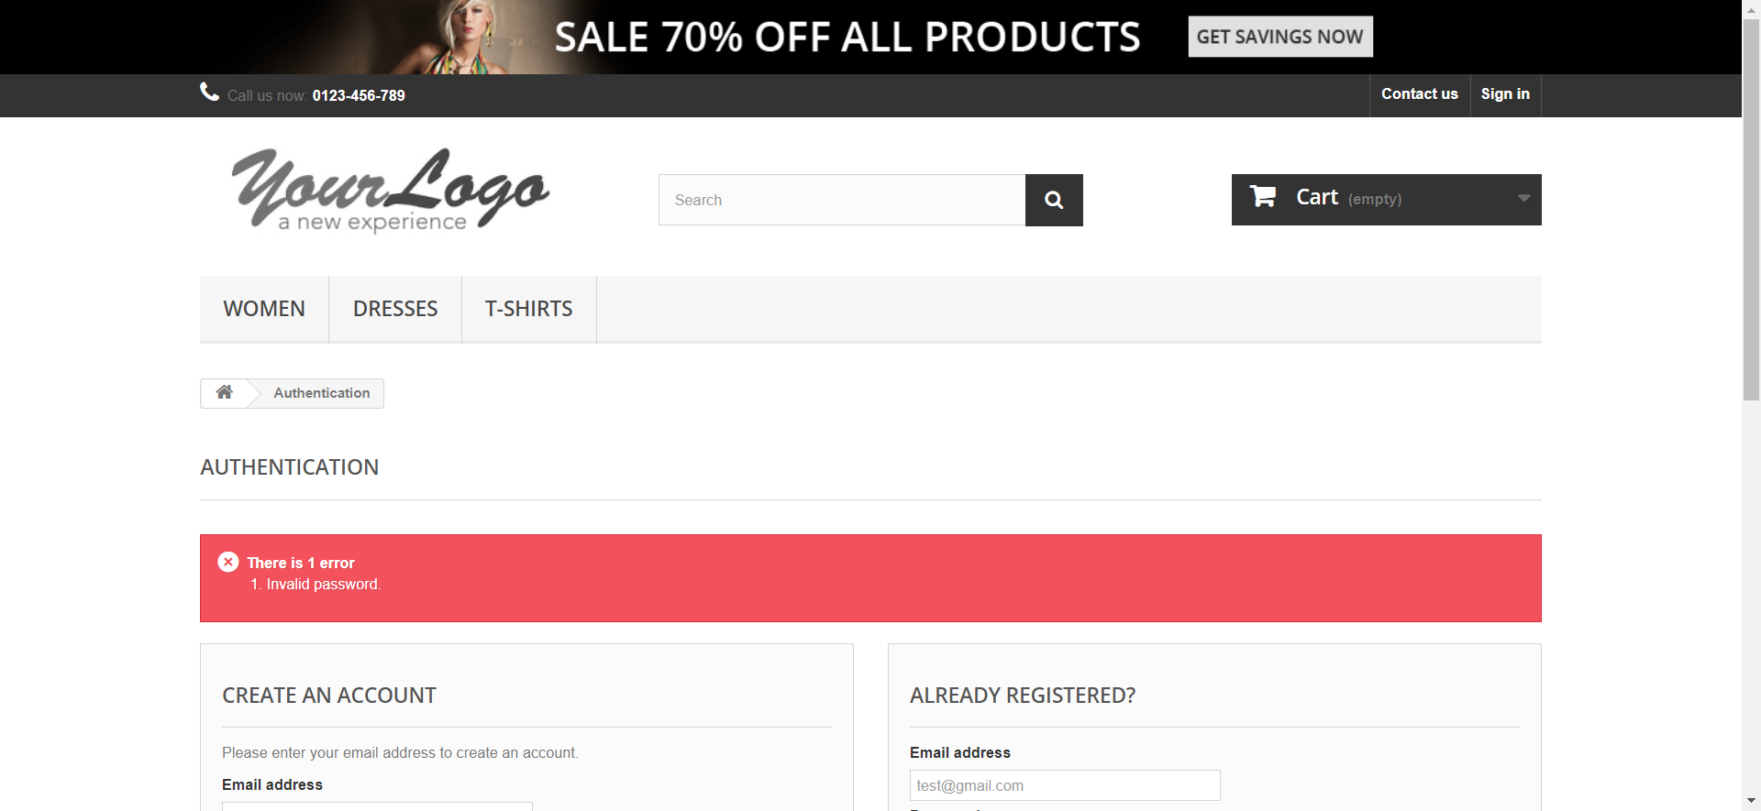

signInInvalidPassword- email:test@gmail.com, password: 1

signInInvalidPassword- email:test@gmail.com, password: 112a

signInRequiredEmail- email:, password: myp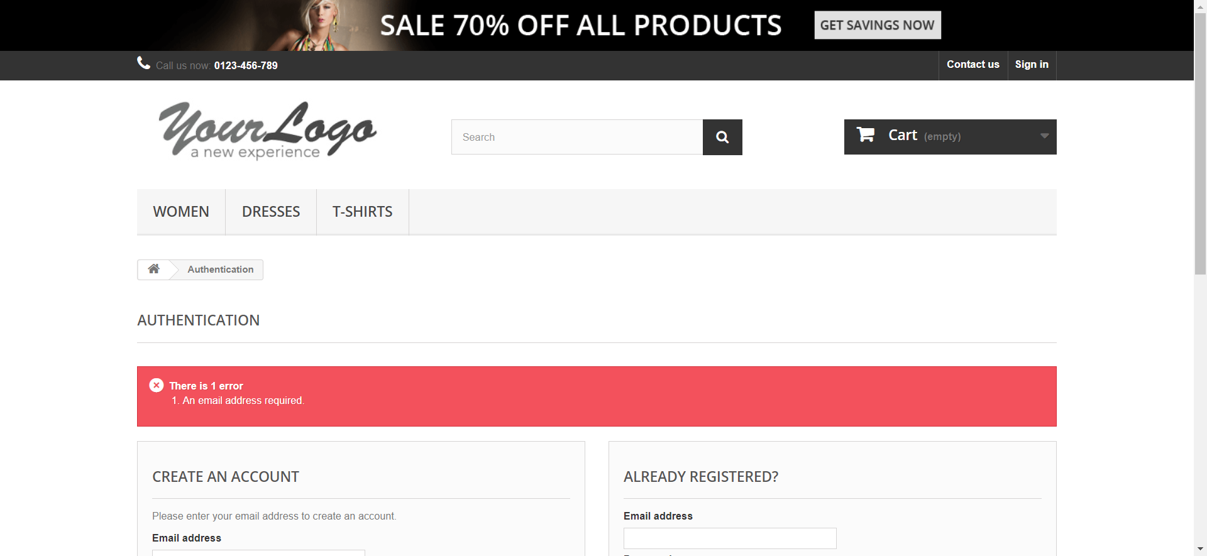

signInRequiredEmail- email:, password: myPassword

signInRequiredEmail- email:, password: 11

signInRequiredPassword- email:micorreo1@correo.com, password: 